1. DECISION TREE
AIM
To implement a simple Decision Tree algorithm using Python to predict whether a student will Pass or Fail based on study hours and attendance.
OBJECTIVE
· To understand the concept of a Decision Tree.
· To use conditions for making decisions.
· To accept study hours and attendance as manual input.
· To predict the student's result.
ALGORITHM
1. Start the program.
2. Read the student's study hours.
3. Read the student's attendance percentage.
4. Check whether study hours are at least 5 and attendance is at least 75%.
5. If true, display Pass.
6. Otherwise, check whether study hours are at least 4 and attendance is at least 70%.
7. If true, display Pass.
8. Otherwise, display Fail.
9. Stop the program.
FLOWCHART:
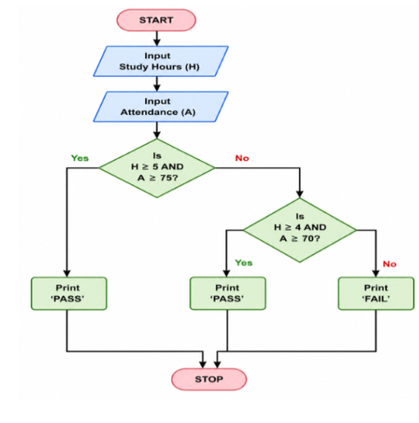
PYTHON CODE:
h = int(input("Enter study hours: "))
a = int(input("Enter attendance: "))
if h >= 5 and a >= 75:
print("Result: Pass")
elif h >= 4 and a >= 70:
print("Result: Pass")
else:
print("Result: Fail")
OUTPUT:
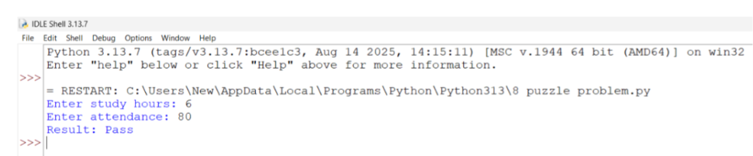
RESULT:
Thus, the Decision Tree-based program was successfully implemented in Python. It accepts study hours and attendance as manual inputs and predicts whether the student will Pass or Fail.

